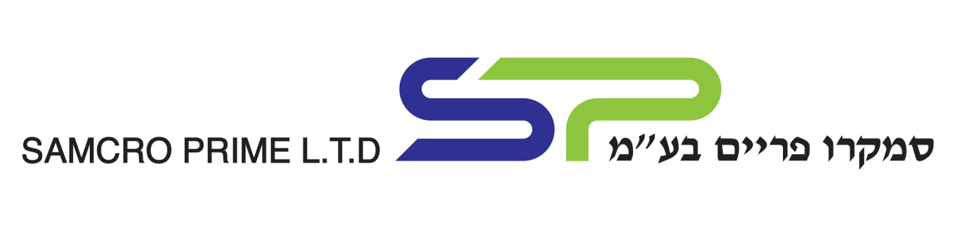
HDPE - extrusion grade
Datasheet

HDPE regrinds & washed blow molding. | Material
Solid Regrind / flakes. | Aspect
Mix color: yellow, transparent, pink, blue, green and black. | Color
Israel | Origin
Jerrycans | income
Post consumer waste. | Source
39151000/5 | HS code
Sewage and drain pipe, silicon core pipe, infrastructures pipe, flexible pipe for electricians. | Applications

Method | Value | Parameter
Visual | Flakes homogeneous | Aspect
190ºc / 2.16 Kg | 0.2 – 0.5 g/10min | MFI
Laboratory | 0.940 - 0.960 | Density
 | 12 mm | Flakes size
 | up to 2% | Surface moisture
Mesh size 100µm | Very clean | Filter test
 | Up to 2% | Impurity pp

